Welcome!
Date
Name
Spouse
Address
City
State Zip _________
Email

Please Contact By
❑ Card  Phone  Visit

Telephone Best Time to Call
Home ______________
Work ______________

Guest: First Time Second Time
Are you a church member: yes no
Church
City, State

Circle Appropriate Age/Grade Group(s)
Preschool: Ages: B-1 2-3 4-5
Children: Grades: K 1 2 3 4 5 6
Youth: Grades: 7 8 9 10 11 12
Adults: Ages:18-29 30s 40s 50s 60s+

How did you learn about our church?
Newspaper Friend Yellow Pages Mail
Other

I am a guest of:

New in the Community? Yes No
Names & ages of children at home

Weekly Service & Activity Schedule

March 8, 2015
9:45 a.m. Sunday School
11:00 a.m. Morning Worship Service
6:00 p.m. Evening Worship Service/Business Meeting

Week of March 8, 2015

Wednesday 7:00 p.m. Adult Prayer & Bible Study
Thursday 10:00 am Adult Fellowship

Upcoming Events
March
22………………………………………………….The Moodys
26………………….………….……………..Adult Fellowship
28………………..…….Community Wide Easter Egg Hunt
April
5…………………………..……………………Easter Sunday


Community Wide Easter Egg Hunt

Saturday March 28, 2015

There will be a box in the foyer of the Sanctuary for candy donations. Anyone wishing to volunteer that day please contact Otisann McManus

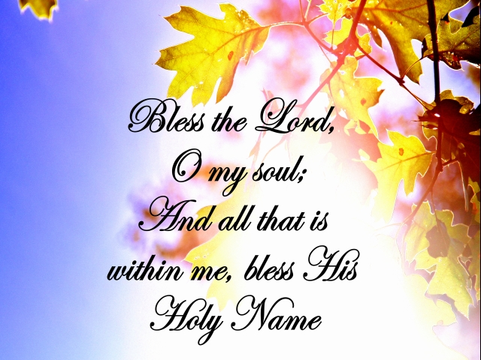

Knobbs Springs Baptist Church

Welcome Bro. Geary McManus

March 8, 2015

Church Information:

KnobbsSpringsBC.com KnobbsSpringsBaptist@gmail.com
1662 CR 305, McDade, Texas 78650 512-273-2743
Patti Radford, Office Manager 512-968-7821

